B KISHORE

192110670

EXPERIMENT – 5

Data Link Layer Traffic Simulation using Packet Tracer Analysis of ARP

Case .1

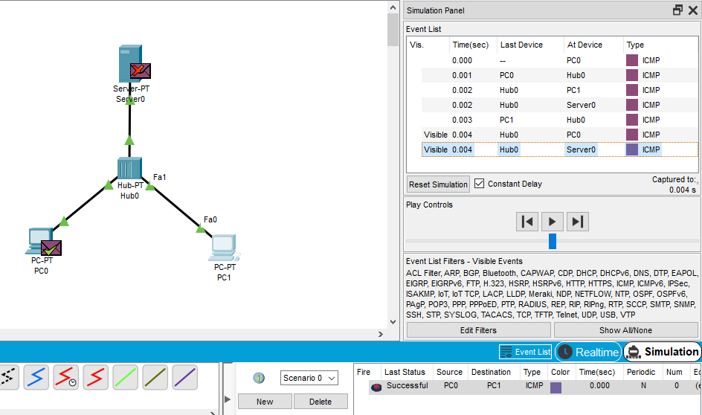

Case .2

